DIOCESE OF DOWN AND DROMORE
APPLICATION PACK
for the Post of:
Ministry Apprenticeship
Scheme Coordinator
(Full-time)

Completed forms should be returned to:
Mr Roy Lawther
Diocesan Secretary
Church of Ireland House 61-67 Donegall Street BELFAST
BT1 2QH
Or alternatively by email to rlawther@downdromorediocese.org
Applications must be received by Friday 19 August 2022 at noon.
Applications received after this time will not be considered.
The interviews will take place in person at Church of Ireland House, 61–67 Donegall Street, Belfast BT1 2QH on Thursday 25 August 2022.

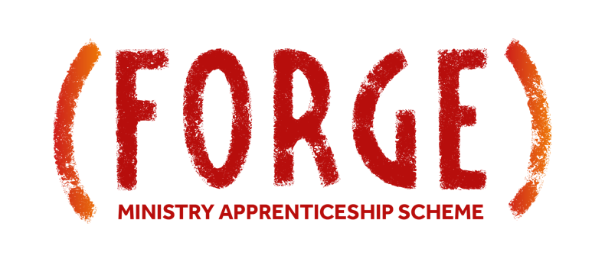

The FORGE Ministry Apprenticeship Scheme

The Diocese of Down and Dromore is commencing a new Ministry Apprenticeship Scheme to enable young Christians (aged 18-25) to develop a strong and enduring faith through training and service in the church.

This new scheme provides an opportunity for young disciples to work and learn in an apprenticeship model with church leaders and their teams in host churches and church plants within the diocese.

Apprentices will be fully involved in the life and witness of their host church and participate in the ministries of the church, especially children’s and youth programmes. Where available, there will also be the opportunity to gain experience in schools’, outreach and compassion ministries. They will also contribute to diocesan-wide ministry programmes such as Saturday Night Live and our Kilbroney Camp programmes.

There will be a strong focus on training in-house within the churches and by the diocese. The scheme will start with induction at the beginning of October, and include monthly training days, group visits to Christian ministries, support to work towards qualifications in either children’s ministry or youth work and an end of year celebration event.

The FORGE programme will begin on Sunday 2 October 2022 and finish on Thursday 31 August 2023.

The Ministry Apprenticeship Scheme Coordinator, in conjunction with the diocesan team, will be responsible for managing the application process for Apprentices, allocating Apprentices to their placement host, organising a welcome and commissioning event, delivering a formal induction, organising development days and other training events as well as supporting Apprentices and placement hosts.

Diocese of Down and Dromore
Job Description
Job Title: Ministry Apprenticeship Scheme Coordinator
Employed by: Down and Dromore Diocesan Council
Reports to: Bishop’s nominated representative
Work base: Based in Church of Ireland House, Belfast.
Work area: The Diocesan area of Down and Dromore and further afield as required.
Summary of Responsibilities
The Diocese of Down and Dromore is a vibrant and growing diocese of 111 church communities and 9 church plants. It is focused on making disciples, raising up and empowering Christian leaders and birthing new ministries and churches.
The Diocese has a parish development team whose role it is to support, encourage and resource parish ministry, including youth and children’s ministry. The Ministry Apprenticeship Scheme Coordinator will work alongside a children’s officer, a youth officer, the Diocesan Development Officer and the wider Diocesan team.
The Ministry Apprenticeship Scheme Coordinator will work with members of the Diocesan team and churches in the diocese to ensure that the objectives of the FORGE Ministry Apprenticeship Scheme are met.
Objectives of FORGE Ministry Apprenticeship Scheme
During their year, Apprentices will:
- grow in their faith
- understand the biblical foundations for ministry
- gain insight into their strengths and weaknesses
- acquire new interpersonal, teamworking, leadership, teaching and evangelism skills
- gain experience in church-based and diocese-wide ministries
- achieve qualifications in youth or children’s ministry
- develop longstanding friendships with Christian brothers and sisters
- have explored a call to Christian ministry
Host churches will:
- extend the reach of their existing ministries
- develop new ministries and outreaches
The diocese will raise up a new generation of ministry leaders
Main responsibilities of Ministry Apprenticeship Scheme Coordinator:
- To promote the FORGE Ministry Apprenticeship Scheme throughout the diocese using a variety of methods including advertising, social media, networks and personal contacts.

- To actively enrol churches as hosts for Ministry Apprentices.

- To organise the recruitment of Ministry Apprentices including the application and interview process.

- To oversee the allocation of Ministry Apprentices to their host churches.

- To partner with host churches as they prepare to receive Ministry Apprentices:

  - Identifying a supervisor and pastoral support for Ministry Apprentices in the host church.
  - Developing a programme of suitable ministry opportunities in the host church for Ministry Apprentices that supports Apprentices to grow in faith, acquire new skills (interpersonal, teamworking, leadership, teaching, evangelism), gain experience in ministry and explore a call to Christian ministry.
  - Planning a programme of host training for Ministry Apprentices.
  - Designing a suitable weekly schedule for Ministry Apprentices that includes the opportunity to attend staff and supervisory meetings, engage in local and diocesan training and participate in ministries in their host church and the diocese.

- To plan and coordinate with host churches a commissioning event and an induction programme for Ministry Apprentices.

- To plan and coordinate monthly ministry development days, group visits and any other group training events.

- To support, in conjunction with the diocesan team, Ministry Apprentices to undertake accredited training in children’s or youth ministry.

- To organise and deliver monthly support meetings with Ministry Apprentices.

- To put in place strategies to support host churches throughout Apprenticeship placements to ensure best outcomes for the scheme.

- To coordinate, in conjunction with the diocesan team, the participation of Ministry Apprentices in diocesan ministries to enable faith development in children and young people such as Saturday Night Live, Kilbroney Adventure Camps, J.A.M Camp and Kilbroney Weekend Blast.

- To plan and organise an end-of-year celebration event for the Ministry Apprenticeship Scheme.

- To engage in regular and effective communication with stakeholders in the Ministry Apprenticeship Scheme across the Diocese and beyond using a broad range of methods including social media.

- To seek to grow the number of Ministry Apprentices and host churches year on year.

- To track, collate and communicate information about the FORGE Ministry Apprenticeship Scheme.

- To assist in supporting other diocesan initiatives as needed.

Hours of work: Full-time.
Evening and weekend work will be required.
No overtime is payable.
Time off in lieu will be granted where additional hours are worked.
Starting Salary: NJC Scale 5 - £22,571 rising to £24,920 depending on experience
Pension: 8% employer contribution.
Term of contract: 3-year contract subject to a 3-month formal probation period
A clear AccessNI check must be received prior to appointment

PERSON SPECIFICATION
Ministry Apprenticeship Scheme Coordinator
Essential criteria:
- Have a committed Christian faith and the ability to work within and maintain the ethos of the Church of Ireland.

- At least 2 years’ experience either in a paid or voluntary capacity of working with young people in a leadership and organisational role.

- Evidence of having grown a children’s or youth ministry in terms of spiritual development.

- Experience of working within Christian environments where pastoral care and theological teaching are delivered.

- A proven ability to organise, lead and teach at events for both young people and leaders.

- Competence in working with Information Technology including word processing, spread sheets, basic design programmes and social media.

- Provide evidence of the ability to work on own initiative.

- Demonstrate or provide evidence of effective interpersonal and communication skills.

- Demonstrate or provide evidence of excellent organisational and administrative skills with attention to detail.

- Educational qualifications at an A-level standard (or equivalent) and 5 GCSE’s (or equivalent) at grades A*- C including English and Mathematics.

- Flexibility and the willingness to work outside of office hours (especially Sundays) and in both formal and informal environments.

- To have a clear Access NI history regarding their suitability to work with children.

- The use of a car and current driving licence.

Desirable criteria:

The following desirable criteria will be applied at short listing should the panel decide that too many applicants meet all the essential criteria. It is important that in making your application, along with the essential criteria listed above, you provide sufficient detail of all the desirable criteria that you think you meet.

- At least 2 years’ experience either in a paid capacity of working with young people in a leadership and organisational role.

- Experience in delivering training programmes to young people and leaders.

- Experience of developing and implementing strategies for change and growth in children’s, youth or families’ ministry.

- The ability to organise, promote and deliver events for both young people and adults.

- Educated to graduate level.

Selection Process:

- Interviews for this post will be held during office hours on Thursday 25 August 2022 with an anticipated starting date for the post of Monday 26 September 2022.

- Candidates selected for interview will be notified by email on Monday 22 August 2022.

- Candidates not selected for interview will be notified by Tuesday 23 August 2022.

- Interviews will last up to 30 minutes and each candidate selected for interview will be asked within this time to deliver a short presentation (of no more than eight minutes) on what strategy they would implement to ensure that the objectives of the post are achieved.

